Contributor: Mariana Westphalen Von Hartenthal

**Figari, Pedro**

Born: Montevideo,1861; Died: Montevideo, 1938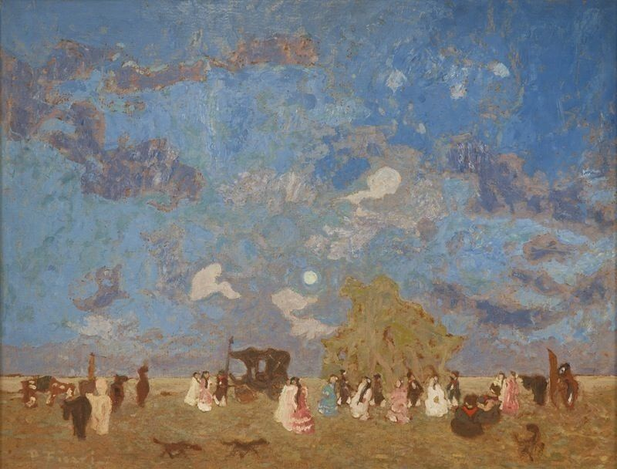

Pedro Figari, *Pique nique*, ca. 1925

Oil on cardboard

65 x 88 cm.

Museo Nacional de Artes Visuales, Montevideo.

<http://mnav.gub.uy/cms.php?o=0957>

Together with his contemporary **Joaquín Torres-García**, Pedro Figari is one of the major names of twentieth-century Uruguay art. Unlike Torres-García and his *Taller del Sur*, however, Figari is not associated with any school or movement, and he left no direct follower. In eloquent brushstrokes, his paintings—oil on canvas or, more often, oil on cardboard—portray the people and landscape of the River Plate region. The sky occupies most of surface of his external scenes, in which the intensity of colors and lack of shadows make it hard to tell whether it is day or night. The low horizon alludes to the vastness and flatness of the *pampa*, populated by gauchos, horses, and the massive *ombú* trees. Subjects are engaged in celebrations, dances, funerals, and everyday activities that take place in the open sky, but also in small town streets, patios, and interiors. In an unprecedented move for a Uruguayan painter at the time, Figari gave prominence to the life of black Uruguayans, especially in his series portraying c*andombes (*Uruguayan celebrations of African origin, accompanied by music and dance). These depictions, however, may seem stereotyped and racist to twenty-first century eyes.

Although he practiced painting as an amateur since his youth, Figari only took up painting as a full-time activity after he moved to Buenos Aires in 1921, that is, when he was sixty years old. Before, he had had a successful career as a lawyer, having started as a defense counsel for the poor, an activity that put him in contact with the more marginalized sectors of Uruguayan society. Throughout his life, Figari was actively involved with his country’s education and politics. In 1893, he worked as a journalist for the newspaper *El Deber*, which he co-directed, and in 1896 he was elected to the Uruguayan Congress. Between 1915 and 1917, he was the director of the School of Arts and Crafts in Montevideo. Figari was also a prolific writer and in 1912 he published a three-volume book exposing his ideas about art and philosophy titled *Arte, estética, ideal*.

The artist did not often give individual titles to his paintings, preferring to work in series in which characters and sceneries are frequently repeated. In 1918, he started his first series, *Piedras* or *Rocas* (Stones or Rocks), in which rock formations are identified with human emotions, such as *Idiotez* (Idiocy) and *Lujuria* (Lust); in 1919 he began the series *Trogloditas* (Cavemen), representing men and women in a primeval state. Unlike these two early series, his following pieces were inspired by the memory of scenes he had witnessed in the past, in his childhood or youth. Therefore, they sometimes have a nineteenth-century appeal, and should not be seen as faithful depictions of real events, but nostalgic reminiscences of a time long gone.

Around 1934, Figari stopped painting. During the short period while he worked as an artist, Figari produced over two thousand pieces and exhibited on many occasions, especially in Buenos Aires and Paris, but also in Montevideo, London, and Brussels.

**References and further reading:**

Ramírez, M. C., Pacheco, M. E., and Costantini, E. (2012) *Modern and Contemporary Masterworks from Malba - Museo de Arte Latinoamericano de Buenos Aires - Fundación Costantini,* Houston: Museum of Fine Arts, Houston.

Camnitzer, L. (1991) “Pedro Figari (1991),” *On art, artists, Latin America, and other utopias,* Austin: University of Texas Press, pp. 131-149.

Linari, G. P. (2006) “Pedro Figari: Criticism of the Avant-Garde and the Utopia of Memory,” *Versions and inversions: perspectives on avant-garde art in Latin America*, Olea, H., and Ramírez, M. C. (eds.), Houston: Museum of Fine Arts, pp. 23-47.

Barnitz, J. (2001) *Twentieth-Century Art of Latin America,* Austin: University of Texas Press.

Figari, P. (1960) *Arte, estética, ideal. Prólogo de Arturo Ardao*. Montevideo.

**List of Works:**

*Candombe*, c. 1925. Oil on cardboard, 62 x 82 cm. Museo Nacional de Artes Visuales, Uruguay.

*Pericón en el patio de la estancia (Pericón in the Ranch’s Patio*), c. 1925. Oil on cardboard, 70 x 100 cm. Museo Nacional de Artes Visuales, Uruguay.

*Potros en la pampa (Colts in the Pampa*), c. 1930. Oil on cardboard, 61,8 x 81,1 cm. Museo de Arte Latinoamericano de Buenos Aires.

*En familia (Close Acquaintances*), before 1938. Oil on cardboard, 49 x 61 cm. ArtStor.

*En la pampa (In the Pampa),* c. 1923-1932. Oil on cardboard, 69 x 99 cm. Museo Historico Nacional, Uruguay.